Davian Perez-Silva

CSET 120

11/22/2017

Time Sheet

(CSET 120)

As a group, we joined slack and started a hangout video chat, we talked about how much work it is possible to finish today by 2:30 PM. From 12:35 PM to 12:45 PM we did our daily stand up meeting but this time it wasn’t face to face. We talked about what each of us were going to do by the end of the day I was going to finish the aside while Edgar and Jessie make progress on the CSS for the main page. Right after the stand-up meeting Edgar and I decided to troubleshoot/pair program our github issue and we ended up resolving it from 12:50 PM to 1:15 PM.

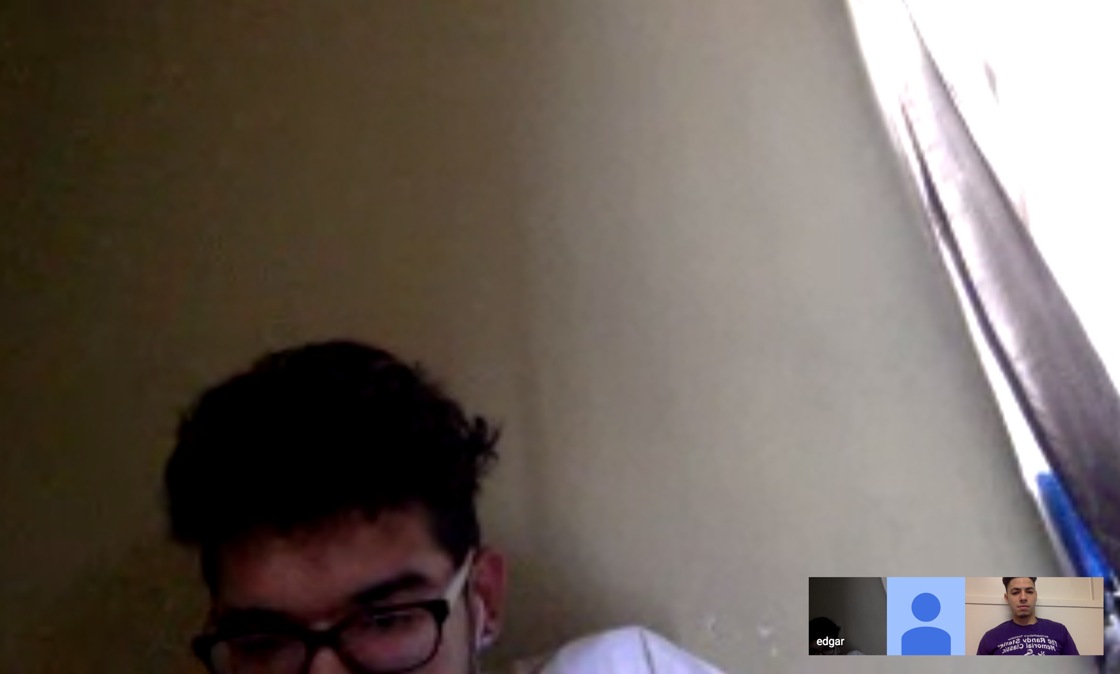

(CSET 115 only)

From 1:15 PM to 1:45 PM I finished aligning the aside bar all that’s left it’s the hover color and to align the right side of the page with the aside bar correctly.

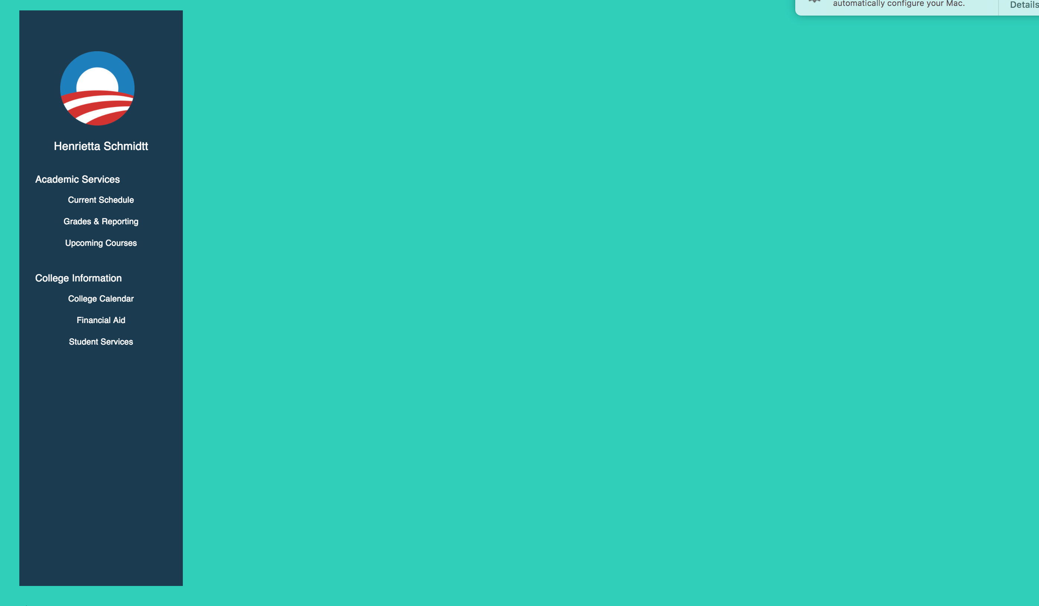

(CSET 120)

Around 1:50 PM I started working on background color for the aside, so when you try to click on it, it will change colors which is known as hover. It took me about 8 minutes to do, I had to add padding-top onto the text which was 10 pixels and then I subtracted 10 pixels from the height of the hover which then made the text align right down the middle of the shade. You notice a lot of red on this image. I deleted a lot of code and use @extend since most of it was repeated and it worked out perfectly. This took me maybe 5 minutes so it was 13 minutes of progress. 1:50 PM – 2:03 PM.

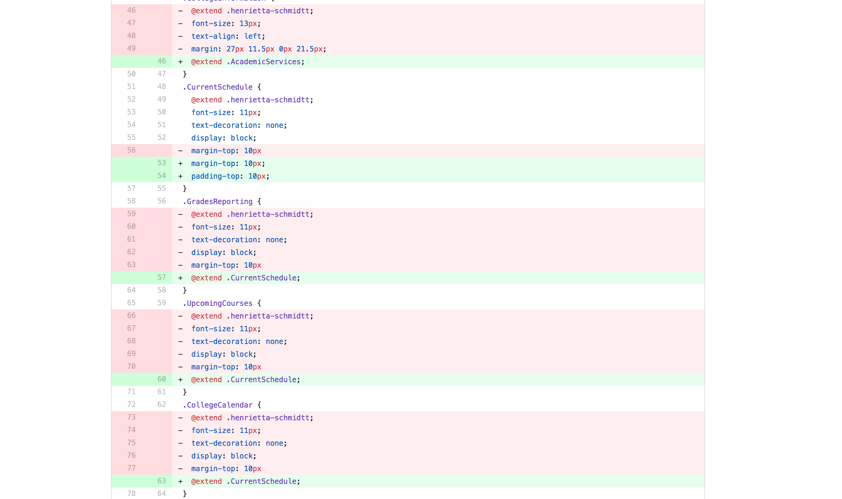

(CSET 120)

From 2:03 PM to 2:30 PM I decided to work an html page and its structure by aligning it better and to see if anybody made any mistakes.

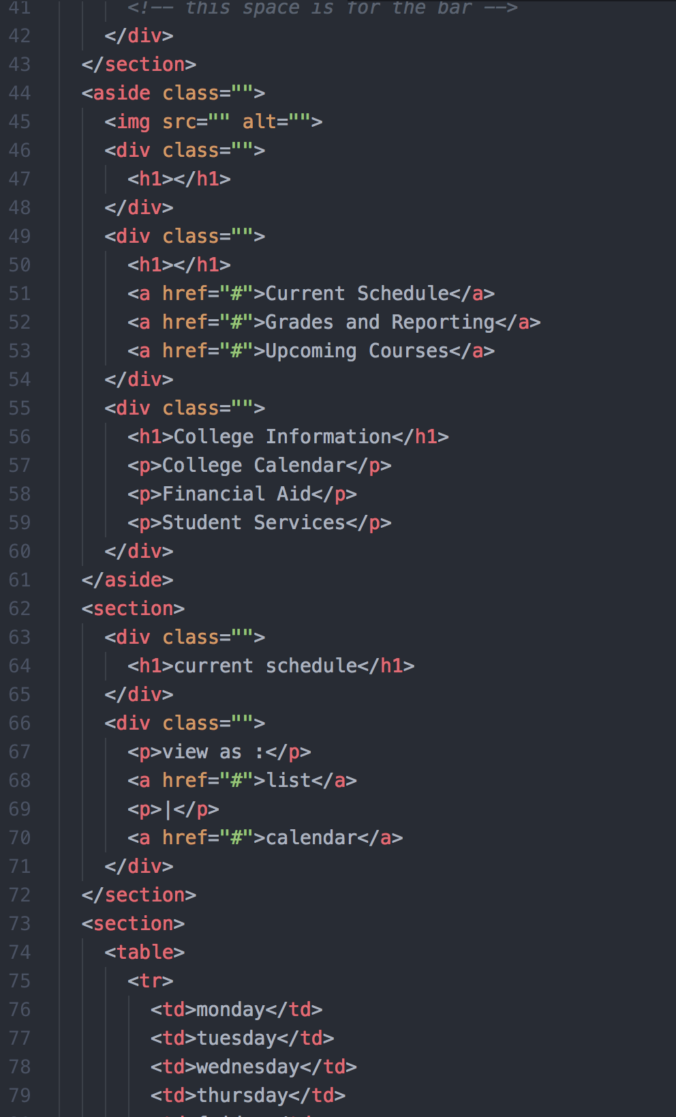

Time stand

12:30-12:36= Got our group together on google hangout

12:36-12:45=Standup meeting

12:45-1:15= Resolved our conflict

1:16-1:20=Separated our work

1:20-2:30= Coded our pages that we assigned